 | America’s  Greatest  Racing  Engine

Historical-data and information update record (5 sheets)

Oct, 2007

Softbound  Page # | Hardbound  Page # | Update Commentary
5 | 21 | On 11-15-04, John Drake, owner of last business producing Offy racing engines, passed away in California. Rod Larmer, of Hillsboro, California, advises that Vince Conze expired in his sleep @ 91 yrs old in April ’05. On 1-22-05, Charles F. (Chuck) Davis, respected Miller race-car authority and one of the founders of the Miller Historical Society, lost his long battle with cancer.
46  (see update below) | 60  (see update below) | Delete sentence beginning, “Goossen used the block design from a V-16…” (Gar Wood Marine V-16 blocks were not related to the 1932 255 design)  (see update below – next page)
54 | 70 | Engine list @ bottom of page – “Lenki & Brisko in-line six cylinders” should read “Lenki in-line six cylinder” Brisko used a split-crankcase design.
73 | - | 1st chart “1940 Champ Car Races…” 8-24 & 9-2 races should be “Winner Powered By” Meyer-Goossen 180
80 | - | 1st chart “1941 Champ Car Races…” 8-24 & 9-1 races should be “Winner Powered By” Meyer-Goossen 180
81 | - | 1st chart “1946 Champ Car Races…” 6-30, 9-15 & 9-22 races should be “Winner Powered By” Meyer-Goossen 180
77 | 93 | Add to end of photo caption, “(Although similar in design and rarity, split crankcases were produced for 220 and 255/270 Offys by both Voelker and Carl Keppler.)”
144 & 147 | 159 & 162 | Smokey Yunick should also be credited with his Offy 252 cam housings modified to run the cams in roller bearings to reduce friction from high valve-spring pressures. No horsepower increase resulted during subsequent dyno runs.
264 & 265 | 274 | In 1947 Meyer & Drake consigned a 97 cu. in. Midget Offy to Convair for testing as an auxiliary power unit (APU) for a USAF rocket project. Although it was cancelled, considerable development-modifications were successfully conducted with the little Offy. (See image further on.)
312 | 322 | Paragraph beginning “The following view into the past…” refers to a “…Jaguar XKE coupe.” The reference should read “…Jaguar XK120 roadster.”
337 | 348 | “1926/30 Miller 151…8 cyls” – should read “…4 cyls”
408 | 421 | 255 Series S/N EXP 400. According to Sonny Meyer, testing with magnesium pistons, titanium rods & wrist pins was conducted. This was 1st racing engine to test titanium parts – albeit unsuccessfully. Learning through years of research to alloy titanium worked for rods & wrist pins.
389 | 401 | Revised “Sheet 2 gear chart” and photo of 10-pitch gear layout is shown further on.

(Update Continued)
469 | 482 | Crankcase front-cover photo caption - late-style cover provided additional drive-gear clearance for a revised oil pump with longer gears
457,458 & 465 | 470, 471 & 482 | Manufacture of round 2-stage oil pump in photos, “Aviad”, is misspelled and should read “Aviaid”.
46  (update) | 60  (update) | In 1932 Miller and Goossen went to Detroit to see Preston Tucker. Back in Los Angeles - in the midst of financial trouble - Offenhauser seized the opportunity to fill an order for a 255 cu in four cylinder. Offehnauser hired R. E. Stevenson to do the drawings. Upon his return, an enraged Miller accepted Offenhausers’ logic and relented to produce four more 255s. In 1934 Offenhauser and Goossen redesigned the 255 to strengthen its structural integrity. The next 255 - and first bearing Offenhausers’ name plate - powered the 1935 Indy 500 winner.
42 | 58 | Miller accepted a substantial deposit from the Sparks-Weirick team for the first Miller/Offy 200 (less pistons, rings, cams & valve springs). But he didn’t like Sparks and sold the first 200 to someone else. An outraged Sparks & Weirick finally got the 2nd 200 only to discover an intake-design flaw (as described in the text) and the crankcase was cracking with alarming regularity. Sparks suspected an inherent imbalance in the crankshaft was causing the ‘case failures. He asked Goossen to redesign the crankcase, add half-moon plates to the crankshaft counterweights, increase the bore & stroke and relocate each intake port to the side of the block. His fixes gave birth to the Offy 220 and continued in use on all future Offys except the Midget.
235 | 246 | By late Summer of 1974, the D-G-S/Offy block drawings and patterns lacked only int & exh-port and combustion-chamber final configurations. With data in hand, Sparks went to Porsches newly-completed state-of-the-art r&d facility in Germany. The DGS/Offy was possibly the first pure-racing engine the new facility ever analyzed to maximize port flow and volumetric efficiency. Upon returning in December (with templates based on the R&D work), Sparks learned of Goossen’s critical condition. He reached the hospital the day before Leo expired. Consequently, the DGS/Offy drawings were never completed. The pattern maker incorporated the pattern revisions using the templates formulated in Germany.
380 | 392 | In "Yr/Eng" column "'32/255..." "Remarks" should read "Offenhauser-Stevenson Offy" & "'65/251..." "Connecting Rod Length" should read "7.00"" & "Ratio" should read "1.778"

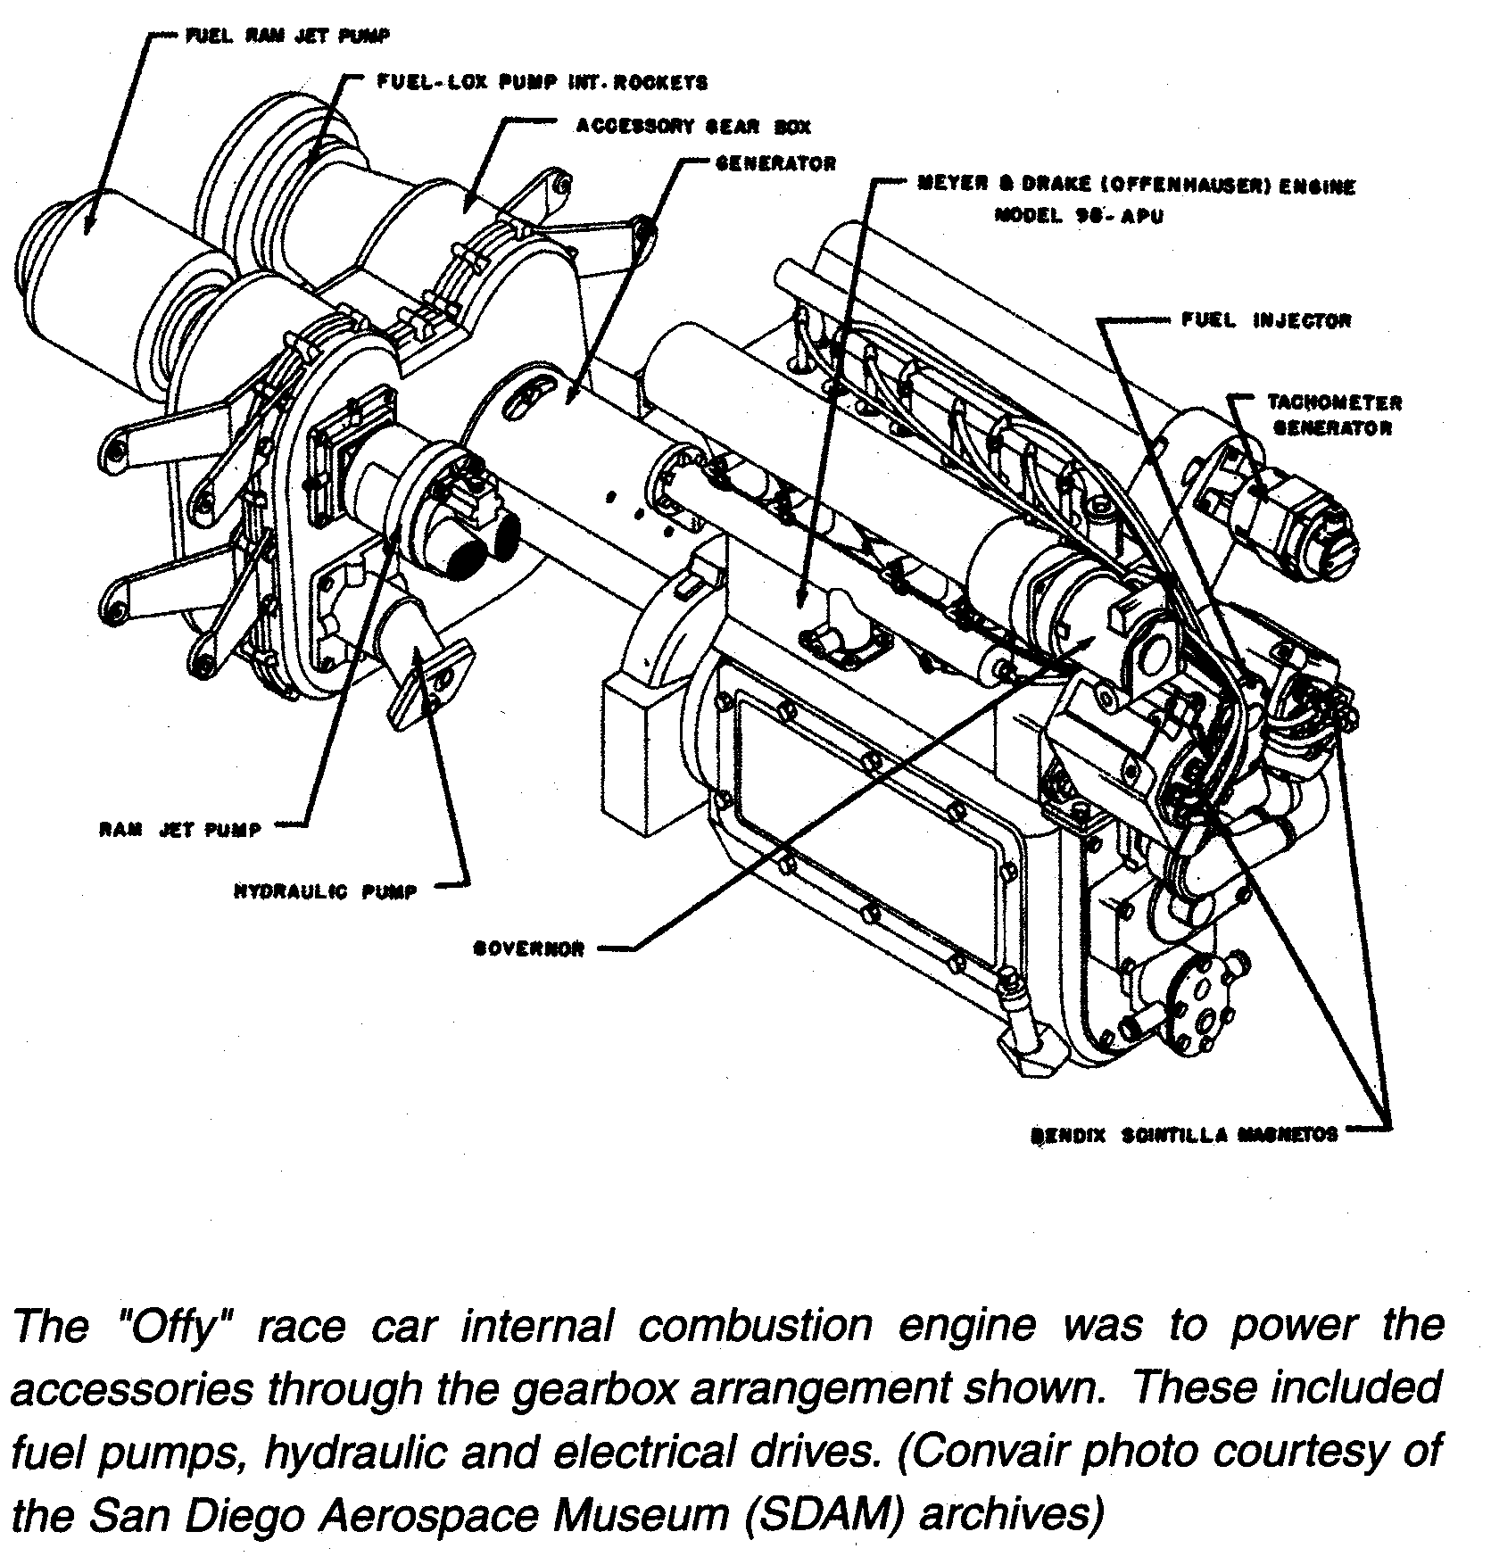

Background Note
In addition to using aviation fuel, to save engine weight, the block was to be cast aluminum rather than iron. Sonny Meyer told me a standard Offy was tested. Notice the number of spark plugs in the illustration above. Jack Hinkles 91 Sports Offy (SN 422 produced in 1954) incorporated 2 plugs per cylinder in a traditional cast iron block. His 270 Offy-powered Indy Roadster – of the same vintage – also featured 2 plugs per cylinder.

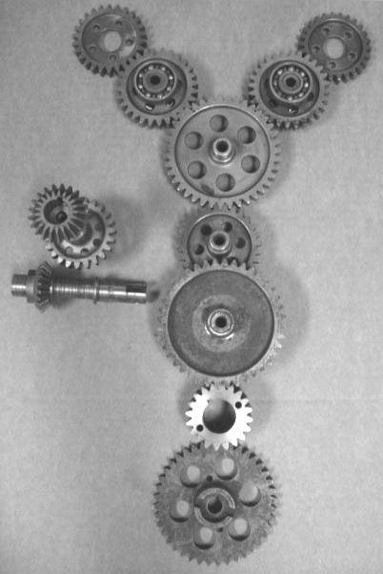
  SHEET 2 Gear Chart
  Gear | Pitch | No. of Teeth
  A | 10  12 | 26  32
  B | 10  12 | 28  24
  C | 10  12 | 39  49
  D | 10  12 | 28  34
  E | 10  12
  F | 10  12 | 23  16
  G | 10  12 | 21
  H | 10  12 | 21
  = I | 10  12  10  12 | 40  56  26  32
  J | 10  12 | 20  28
  K | 10  12 | 40  50
  = Dual Gear - Front crank-gear driven - Rear drives gear-train to camshafts & accessory-drive
Magneto-Drive idler gear (E) is missing in 10-pitch gear layout above. Reliable 12-pitch bevel gears were retained. Notice Oil/Water Pump-drive gear (bottom) is slotted type. Alternative design had internal splines for late style water pumps with splined-shaft.

Index of full-page photos taken by the author at the Trenton Speedway in 1963 & ’64

Hardbound page # | Softbound page # | Year | Driver(s)
4 | i | 1963 (not ’64 as shown) | Lloyd Ruby
7 | - | “ | Don Branson
8 | vi | 1964 | Johnny White
- | ix | 1963 | (unknown)
15 | xvi | 1964 | Lloyd Ruby
18 | 2 | 1964 (not ’63 as shown) | * Parnelli Jones
20 | ii | “ | Bobby Marshman
22 (same as page 8) | 6 (same as page vi) | - | -
71 | - | 1964 | Bob Mathouser
325 | - | “ | * Mario Andretti
326 | - | 1963 | (Did Not Qualify)
338 | 327 | 1964 | * A. J. Foyt
345 (same as page 4) | - | - | -
346 | 342 | 1964 | Chuck Rodee
 | 349 | “ | Bob Mathouser
353 (duplicate of page 71) | - | - | -
354 | - | 1963 | * Parnelli Jones
360 (same as page 325) | - | - | -
370 | 368 | 1964 | * Mario Andretti & Norm Hall
380 | 376 | “ | Chuck Hulse
388 | 382 | “ | Bobby Marshman
394 | 403 | “ | Ed Kostenuk
415 | 413 | “ | * Roger Ward
416 |  | “ | * Troy Ruttman
426 | 421 | “ | Chuck Rodee & Bob Harkey
454 | - | “ | Bruce Jacobi
- | 483 (same as page 403) | - | -
498 | - | 1964 (not ’63 as shown) | * Parnelli Jones
508 (same as page 4) | - | - | -
* former Indy 500 Winner

