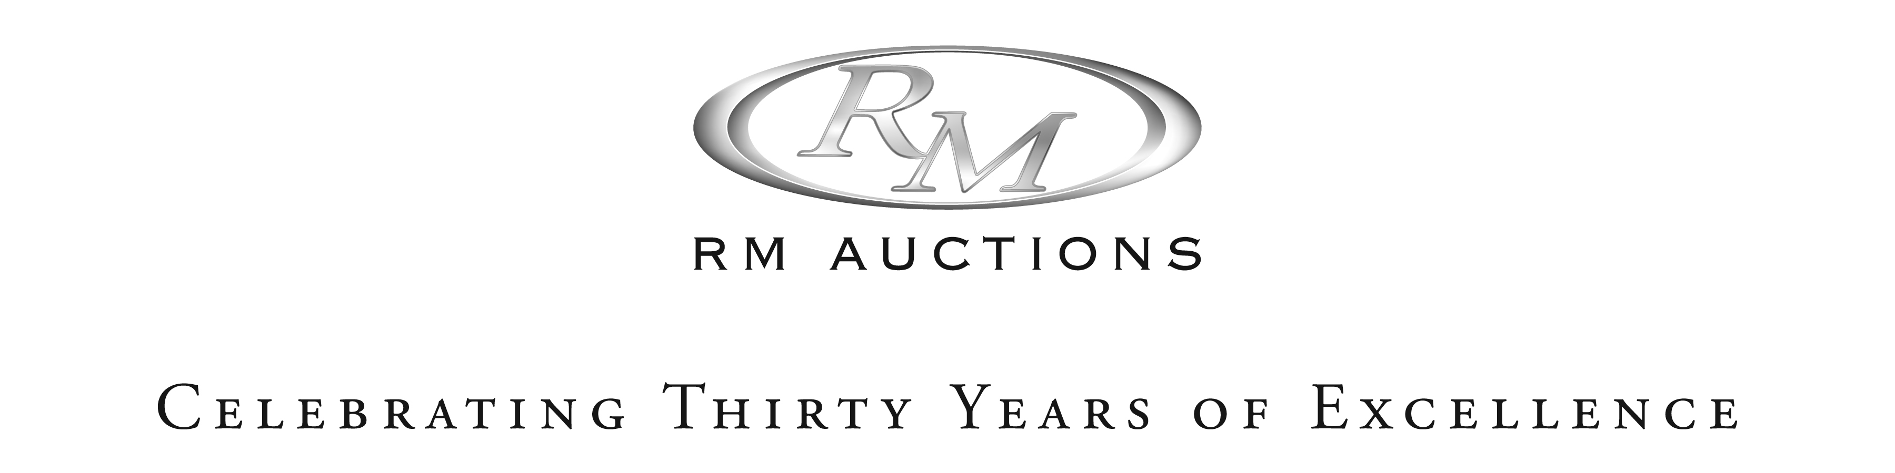

** UPDATED**

RM AUCTIONS ANNOUNCES CONSIGNMENTS FROM TWO IMPORTANT US COLLECTIONS FOR HERSHEY AUCTION

- RM Auctions extends annual ‘Vintage Motor Cars of Hershey’ auction program to two days – October 8th& 9th, 2009
- Notable consignments include a series of automobiles from Ohio’s esteemed Crawford Auto Aviation Museum and over 400 lots of memorabilia from a private East Coast collection.

BLENHEIM, Ontario (September 2, 2009) – Preeminent international auction house, RM Auctions, is delighted to announce consignments from two important US collections to its annual Vintage Motor Cars of Hershey event – a magnificent series of motor cars from Cleveland, Ohio’s esteemed Crawford Auto Aviation Museum, a collection of the Western Reserve Historical Society, and over 400 lots of memorabilia from a prominent East Coast collector.

These latest consignments have seen the addition of a second day to this year’s auction program – now scheduled for October 8th and 9th - with some 140 motor cars and over 450 lots of memorabilia to be offered during the two days. Returning to the Hershey Lodge, the auction will again coincide with the famed AACA Eastern Division Fall Meet to make for a memorable vintage car weekend for motoring enthusiasts.

“The Crawford Auto Aviation Museum is regarded as one of North America’s premier automotive collections. We are honored to have been selected to present a series of automobiles from this property of the Western Reserve Historical Society at our upcoming Hershey event,” said Ian Kelleher, President and Chief Operating Officer of RM Auctions.

“Each lot has been carefully preserved and many are coming to market for the first time in a number of years after long-term display, resulting in strong early interest amongst serious collectors,” he added.

Headlining the consignments from the Crawford collection is a 1949 Belanger Special Indy Roadster. This important racing car is known to have some early Indianapolis racing history and is presented in its blue and gold 1949 livery, the way it was raced in the Indy 500 by Duane Carter. It has a fascinating history that even includes the motion picture To Please A Lady, starring Clark Gable. Formerly owned by the famed Harrah’s collection, it has been part of the Crawford Auto Aviation Museum, a collection of the Western Reserve Historical Society since 1991 and offers a rare opportunity to purchase a unique piece of Indy racing history.

Also on offer and expected to draw considerable interest is extremely rare and desirable 1928 Front Wheel Drive Miller 91 Engine, originally owned by the Mike Boyle racing team. Boyle driver, Fred Comer, constructed a unique and unusual intercooler of 72 half-inch copper tubes, each approximately nine inches long, for the engine. This important piece of automotive history was acquired by Mr. Crawford during the 1930s. It was prominently displayed at the Thompson Auto Album from the late 1940s through early 1960s before gifted to the Western Reserve Historical Society by Mr. Crawford in 1964. It is arguably one of the most important Miller artifacts to come in the market in decades having been in single ownership since the 1930s.

In total, 24 cars from the collection are slated for RM’s Hershey auction. Other highlights include; a 1975 Cadillac Eldorado Convertible, formerly owned by Bill Mitchell, former head of Cadillac design; an all-original 1973 Jaguar E-Type with just 11,000 miles from new; a 1976 Cadillac Brougham, used by Milton Wolf of the Austrian Embassy; and a well-documented 1930 Bugatti Type 44 Touring and a 1919 Locomobile Type 48 Series 5 Sportif, both of which have been on long-term display at the Crawford. The selection of cars slated for the Hershey auction follows the recent sale of two other important cars from the Crawford Auto Aviation Museum at RM’s recent Monterey event – a 1966 Aston Martin DB5 and a 1956 Mercedes-Benz 300SL Coupe, both of which attracted spirited bidding and well-exceeded their original pre-sale estimates.

In addition to the motor cars, the event will feature over 400 lots of memorabilia from a prominent East Coast Collector. Carefully amassed over the past two decades, the collection includes everything from rare and iconic original neon and porcelain signs, through to automotive badges, mascots, specially commissioned artworks by renowned automotive artists including Ken Eberts and Tom Hale, and a plethora of automotive models and toys.

RM’s Vintage Motor Cars of Hershey event will be held October 8th and 9th, 2009 at the Hershey Lodge, West Chocolate Avenue & University Drive. Hershey, Pennsylvania. A full day preview will commence on Thursday, October 8th from 9am, with all the auction action getting underway from 12noon – 8pm. On Friday, doors open at 9am with the auction commencing at 2pm.

As a prelude to the auction, RM will again team up with the AACA and the AACA Museum as the presenting sponsor of this year’s Night at the Museum event, to be held October 7th, 2009 at Hershey’s AACA Museum. With all proceeds supporting the AACA family, this gala fundraising evening – featuring an exclusive charity auction and guest presentation by renowned automotive journalist, David E. Davis, Jr. - will be an engaging celebration of the automobile and the collecting hobby, and a great start to this year’s Hershey Meet week.

For further information on RM’s Vintage Motor Cars of Hershey event, please visit www.rmauctions.com or call +1 519 352 4575. For further information on the Night at the Museum fundraising gala, please visit www.nightatthemuseum.org or call 717 566 7100 ext 101.

About RM Auctions
Celebrating 30 years in the collector car industry, RM Auctions and its associated companies are responsible for acquisitions, restorations and sales of the world’s rarest and most valuable vintage automobiles, including record-breaking sales in Maranello, Italy and London, England. RM’s restoration division achieved unprecedented accolades in 2006, when the Company earned “Best of Show” honors at the world’s top three collector car events in a single year. www.rmauctions.com

About the Western Reserve Historical Society and its Crawford Collection
The Western Reserve Historical Society, a private, nonprofit 501(c)(3) educational institution, encourages the public to explore the history of Northeast Ohio and its impact on regional, state, national, and international history. Founded in 1867, it was the first cultural institution of the Cleveland area and is one of the oldest historical societies in the nation. The Crawford is one of several collections including artifacts, archives, and costumes, that help tell the vibrant story of Northeast Ohio.

About the AACA
The Antique Automobile Club of America is an international organization with members in all 50 states and in more than 50 countries around the world, with over 400 AACA Regions and Chapters. Formed in 1931, the aim of the AACA is the perpetuation of the pioneer days of motoring by furthering the interest in and the preservation of antique automobiles, as well as the promotion of sportsmanship and of good fellowship among all AACA members. Today, the AACA is the largest club in the world dedicated to furthering interest in and preservation of antique automobiles and their history. For more information on the AACA organization and events visit www.aaca.org.

** Photo caption - 1949 Belanger Special Indy Roadster. (photo: Darin Schnabel).

Media Contacts

If you are interested in attending this event as a member of the media, please visit www.rmauctions.com/credentials to register for media credentials. For further information, interview opportunities and hi-res images, please contact:

Amy Christie achristie@rmauctions.com +1 519 437 3047
Kerrey Kerr-Enskat kkerrenskat@rmauctions.com +1 519 437 3053

